1.MainMenu:
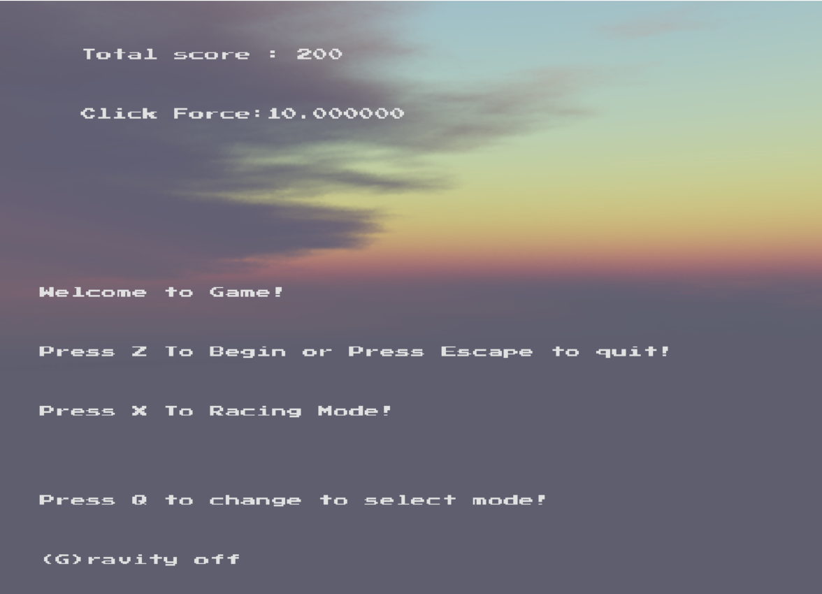
//Press Z to enter Part1
//Press X to enter Part2
//Press ESCAPE to CLOSE the GAME
2.Part1:
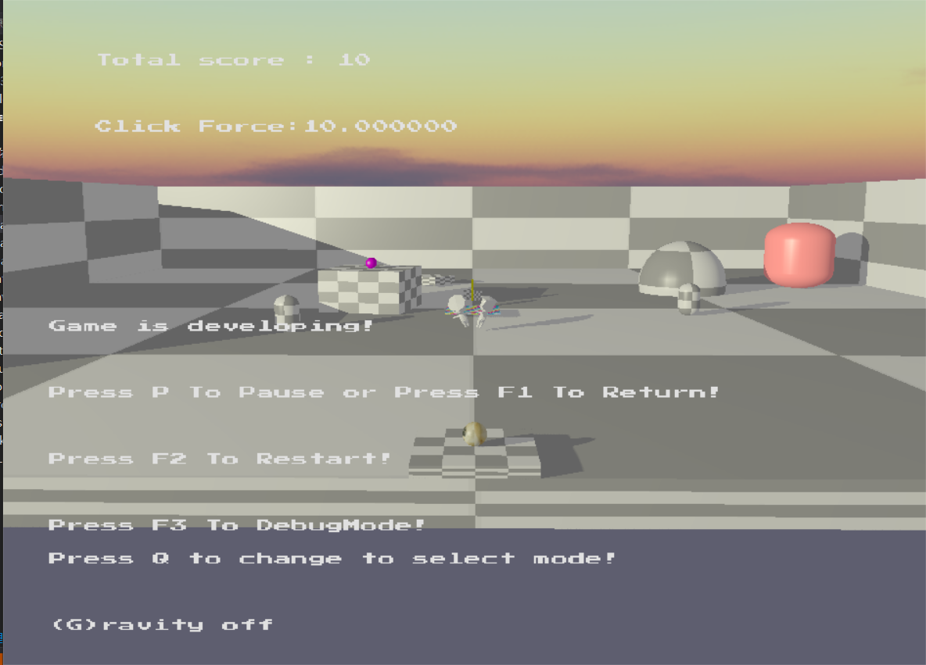
//Press F1 to Return the MainMenu
//Press F2 to Restart GAME
//Press F3 to Enter the DEBUG Mode
//Press P to Pause
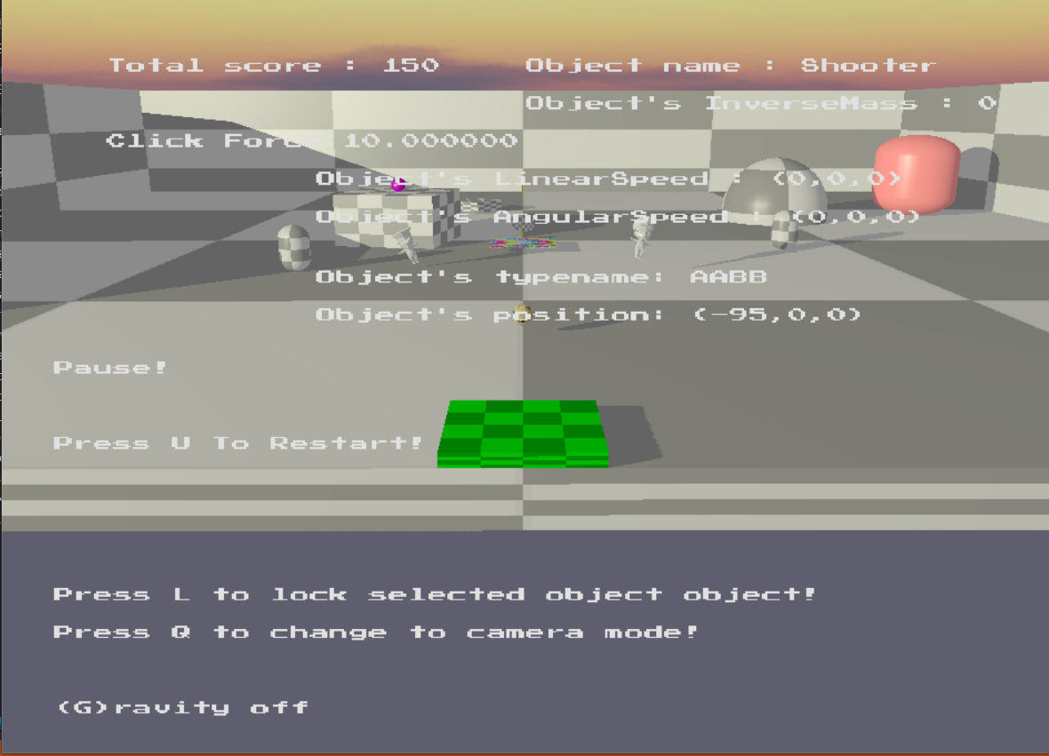
//The “player” Ball will initially be landed on the special “floor”(which is a AABB called Shooter).
//When we select the Shooter floor,the “trigger” of the special floor will be open , and the ball will be LAUNCHED!
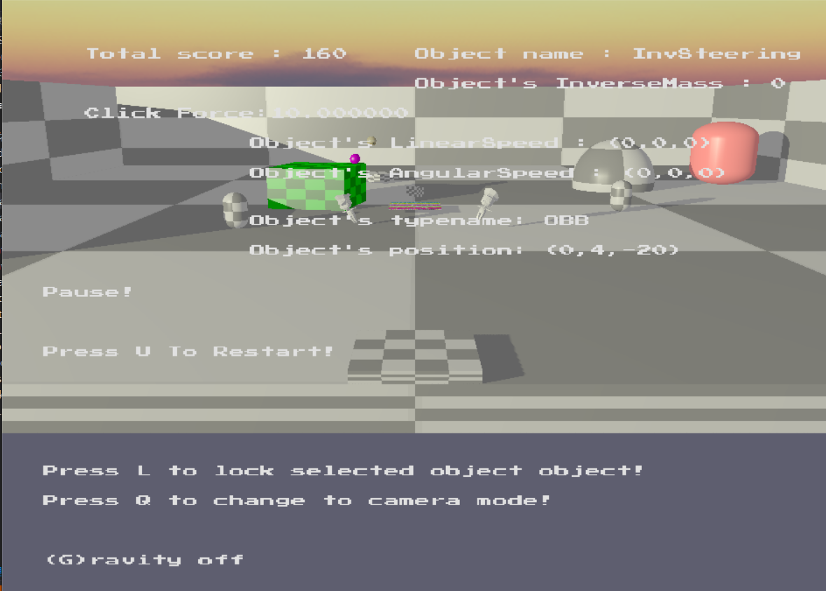
//After being LAUNCHED by Shooter,the next position of the “Player” ball will be on the box(be BOUNCED by other objects in the scene!)
//Then we need to click the box,which is called “InvSteering” having the similar property as the “Shooter”,to make it selected.
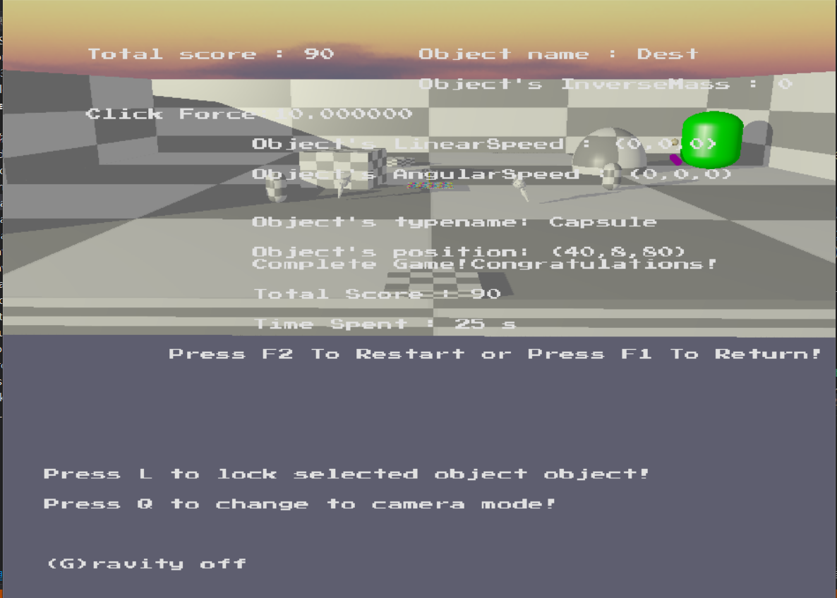
//The “InvSteering” box will LAUNCH the “Player” ball to the “Destination” Capsule
//If the “Player” ball or “Attachment” Capsule have collided with the Destination,the game will be COMPLETED!


//In Part1,we have 200 Points initially,and 10 points will be deducted for every second that passes.
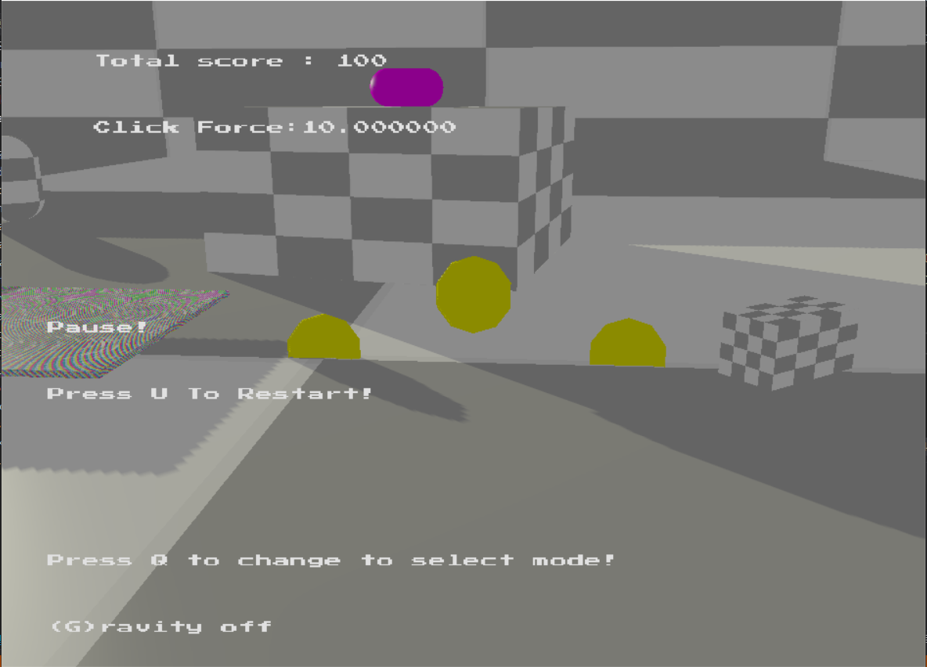
//There are also some “PointCoins”,which are state objects,that can be collected to gain extra 10 score.

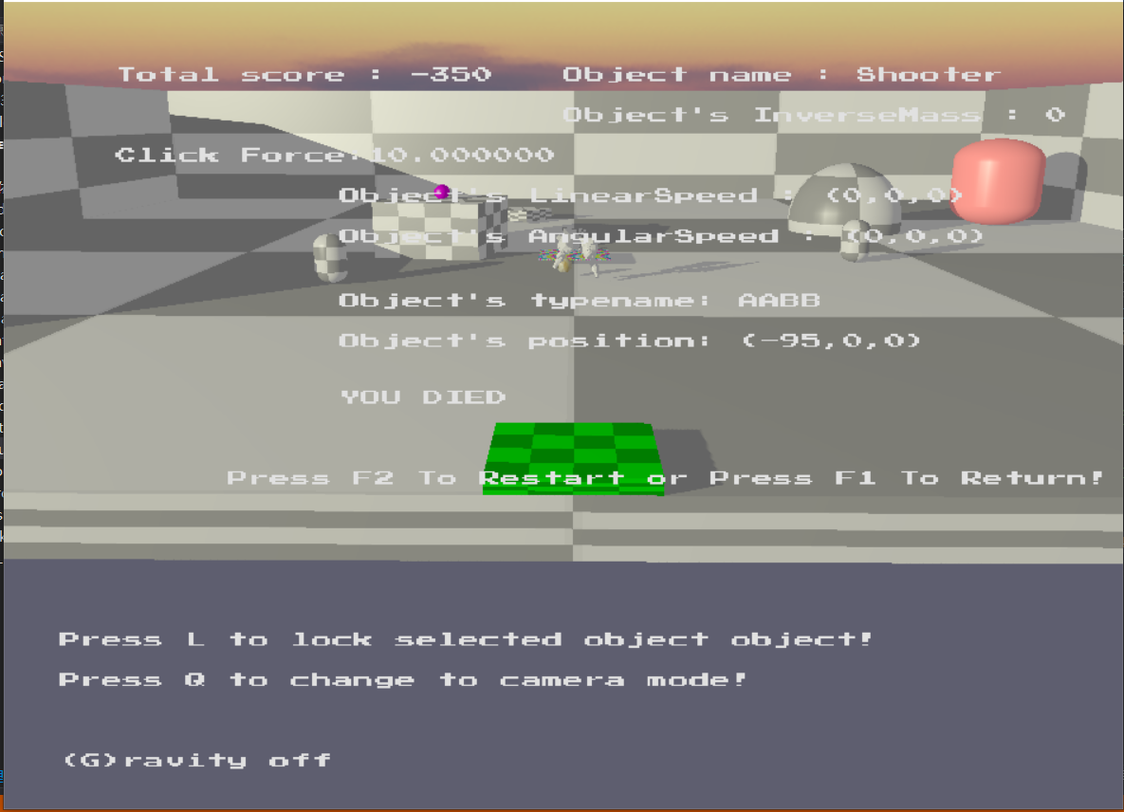
//There are two wandering “Enemy” in the scene,and if “Player” ball has collided with the “Enemy”,our score will be deducted by 500,so will the game be DEAD.
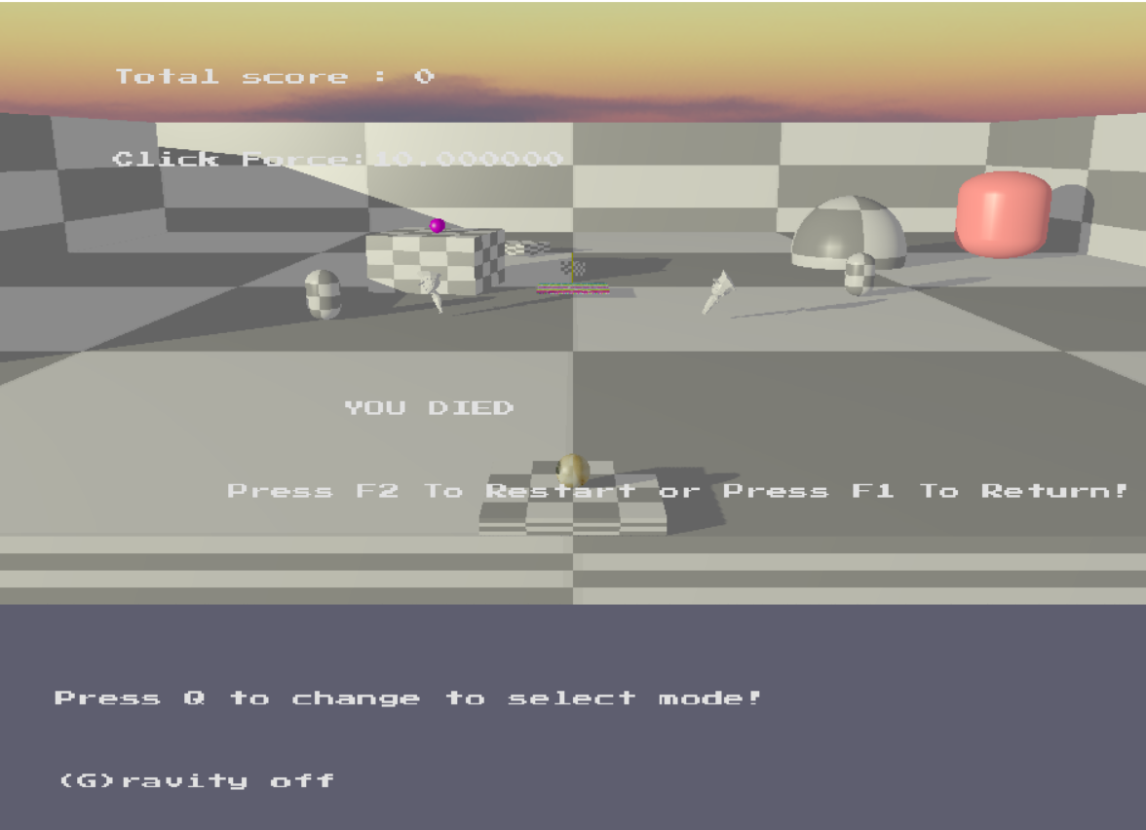
//If the score = 0,the game will be DEAD.
- Part2:
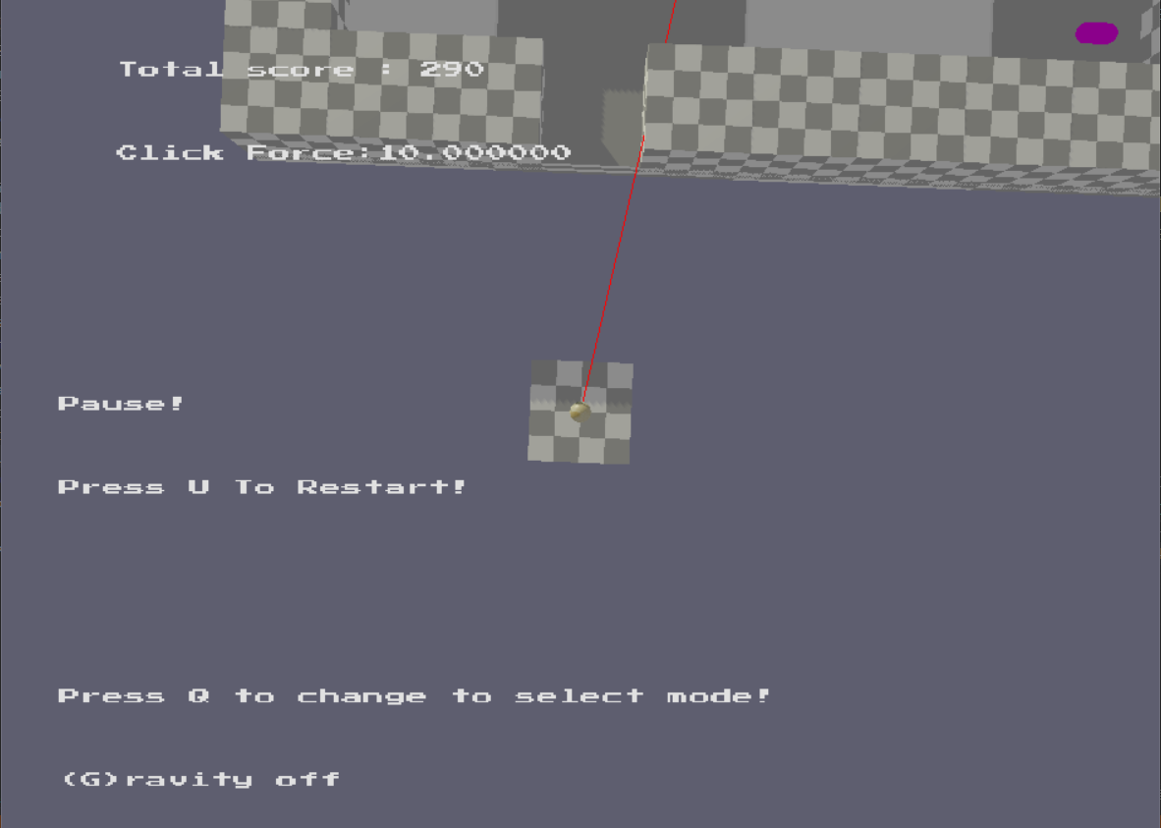
//Press F1 to Return MainMenu
//Press F2 to Restart
//Press F3 to Enter DEBUG Mode
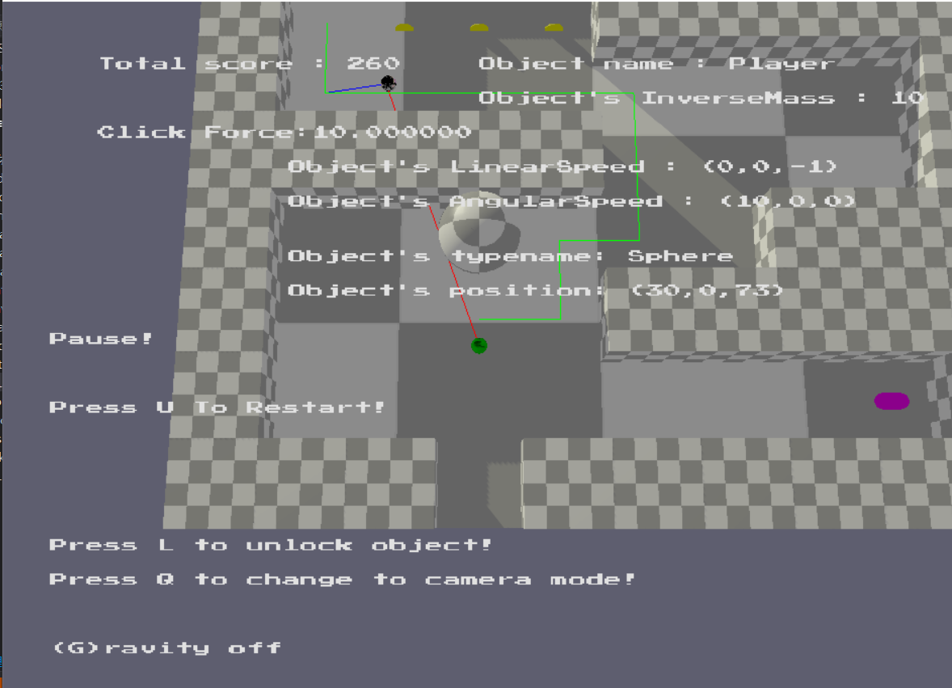
//Our “Player” ball will firstly be LAUNCHED by special floor just like what we have seen in Part1.
//We need to select the “Player” ball and Press L to make our ball become LOCKED
//Then we can make the ball moving by Press UP,DOWN,LEFT and RIGHT.
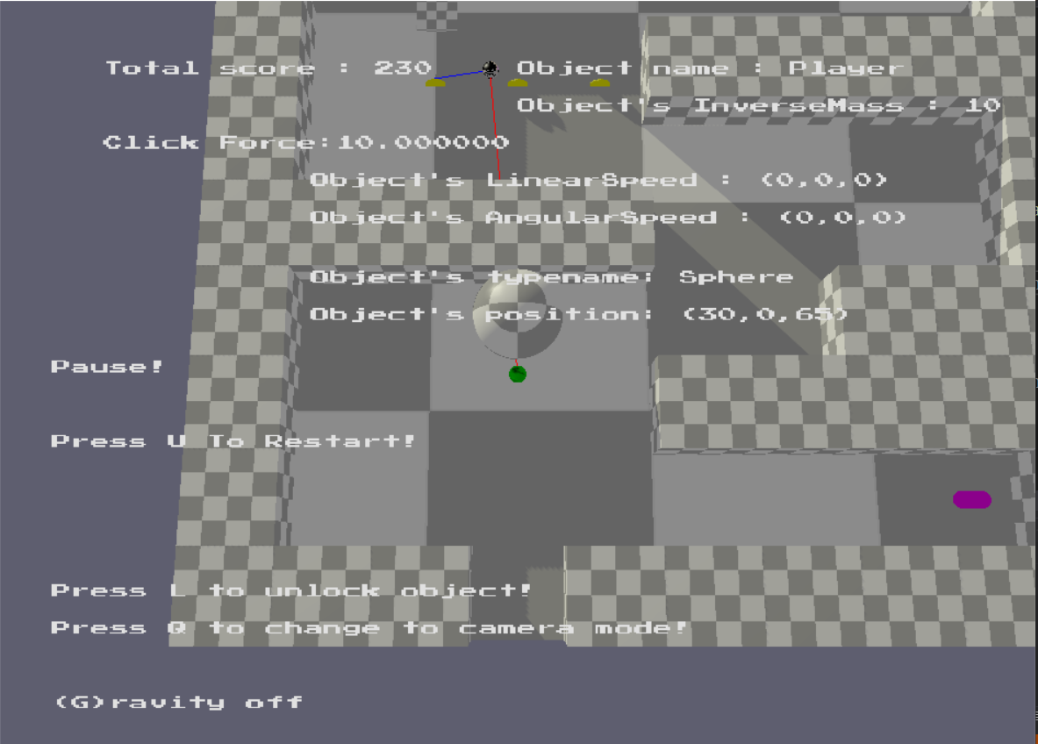
//There is an “enemyball” in the maze,and it will initially move to the point coin.
//After collecting the first point coin,the “enemyball” will come to catch “Player” ball.
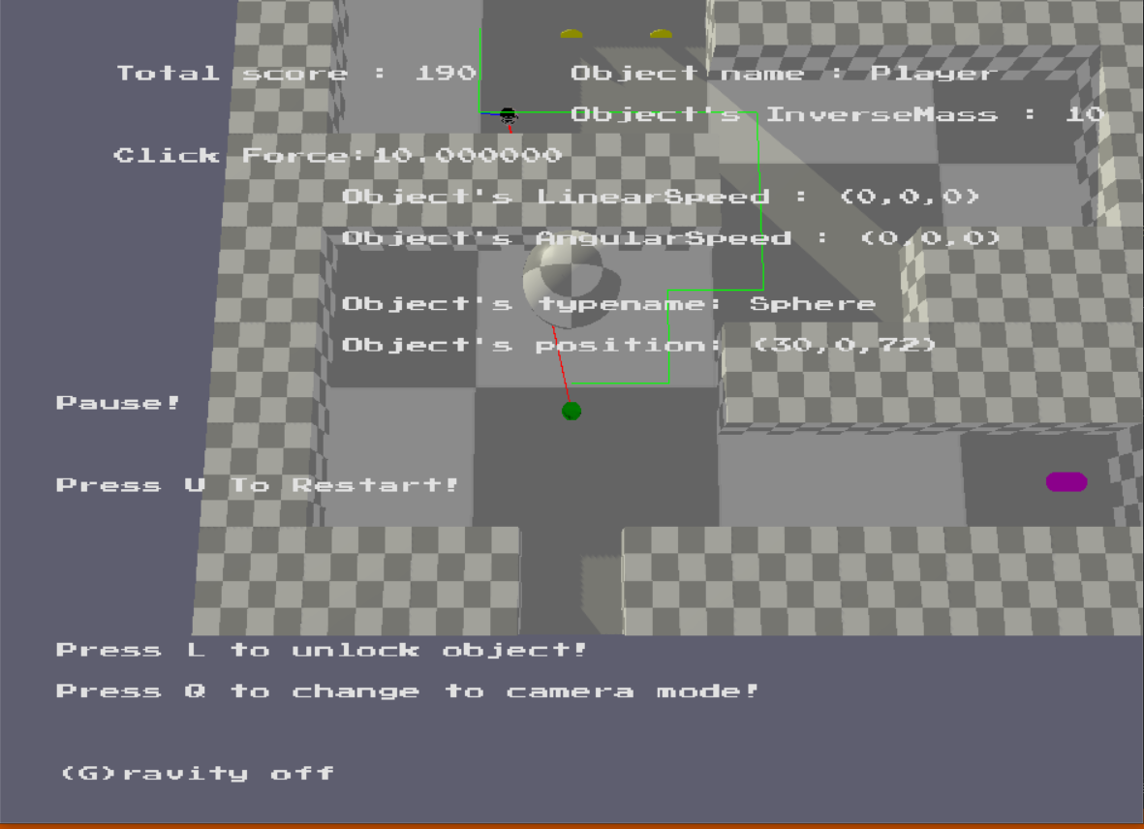
//If the “EnemyBall” can’t “see” the “Player” ball,it will use A* pathfinding.
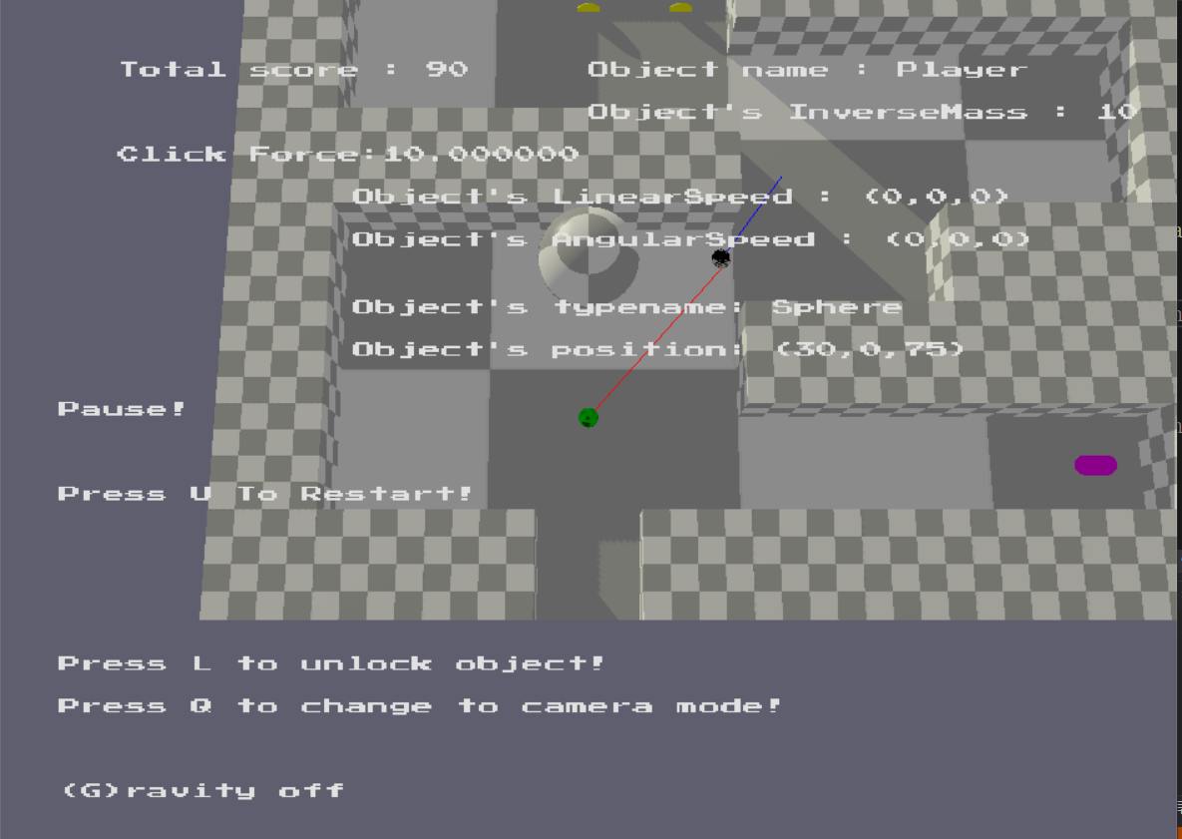
//If “EnemyBall” can “see” the “Player”,it will straightly move towards the “Player” ball,using Raycasting.
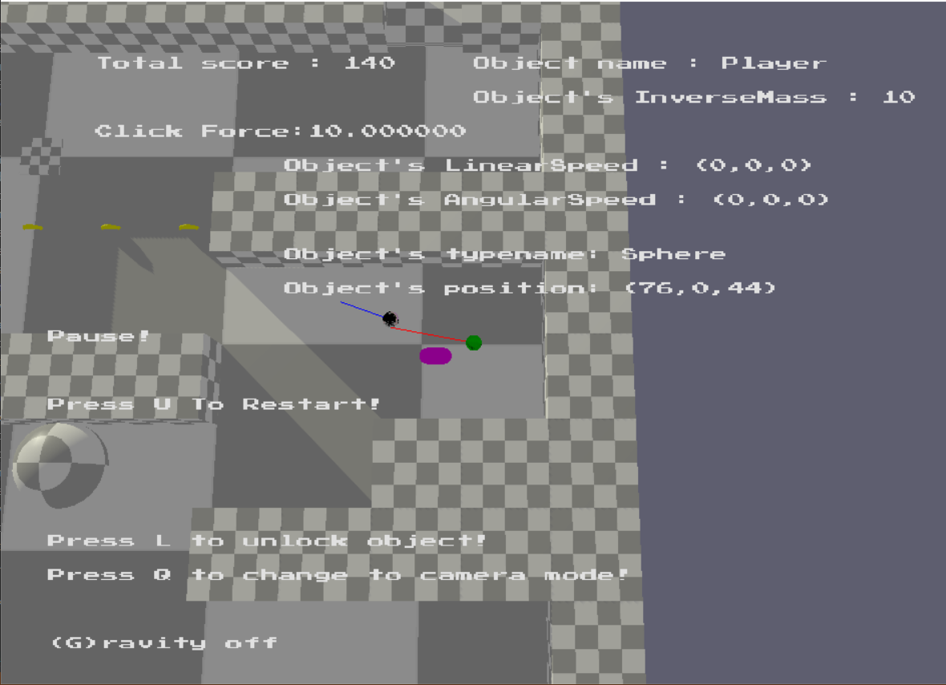
//There are extra powerups in the maze,like the purple capsule at the corner.
//When we get close to the capsule,it will build position constraints with our “Player” ball,and we will gain extra 50 score.
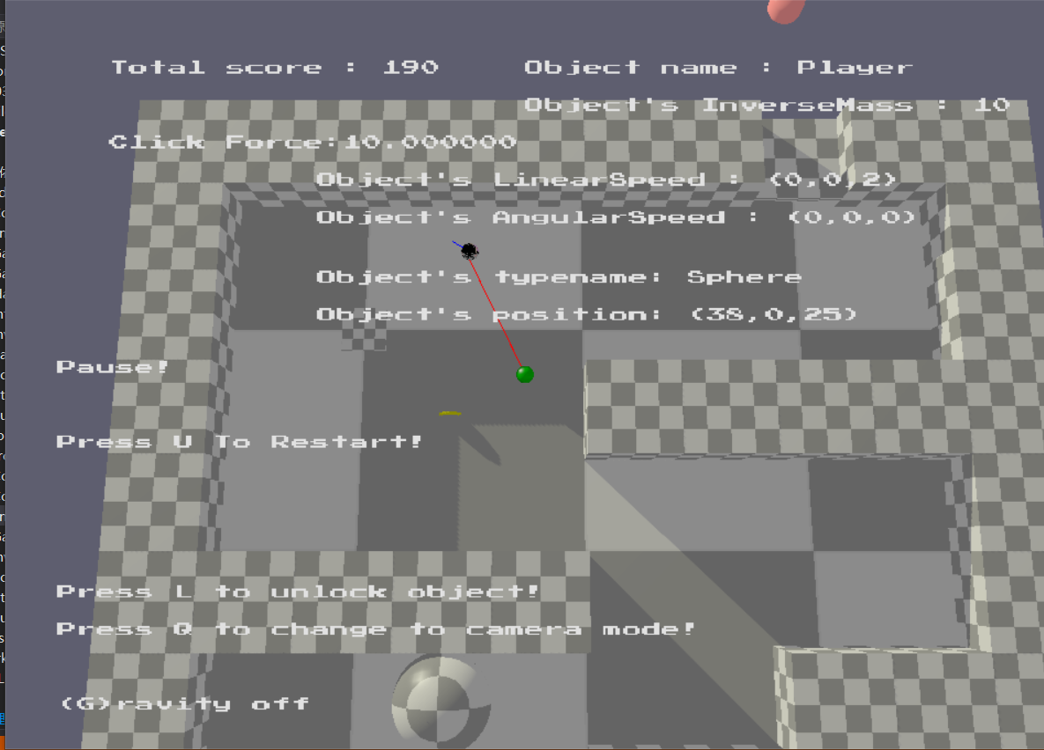
//There are also three point coins in the maze ,collecting each will give us extra 10 points.
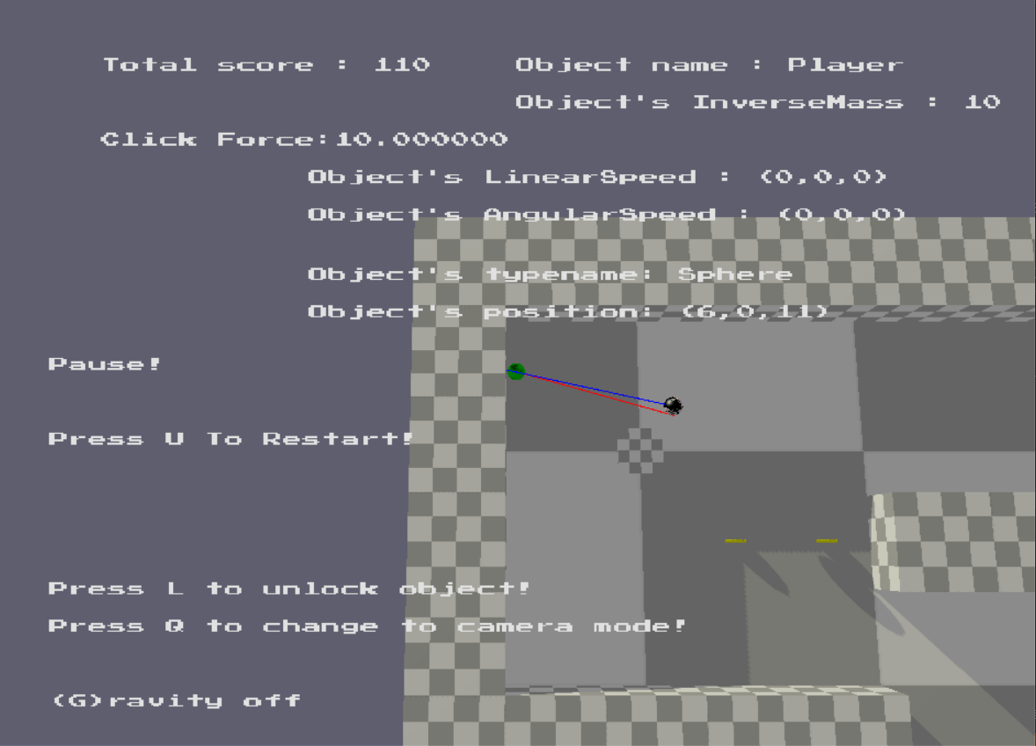
//There is a special floor in the maze,which is called Freeze.If the “EnemyBall” collided with the “Freeze”,it will be freezed for 5 seconds.

-In Part2,we will have 300 score initially,and 10 points will be deducted for every second that passes.
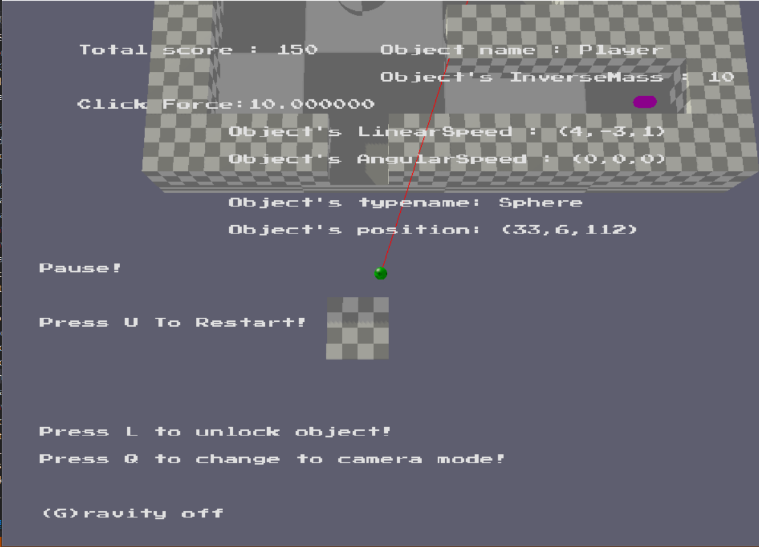
//If the “Enemyball” has “catched” the “ Player” ball,they will both Respawn at their initial position.
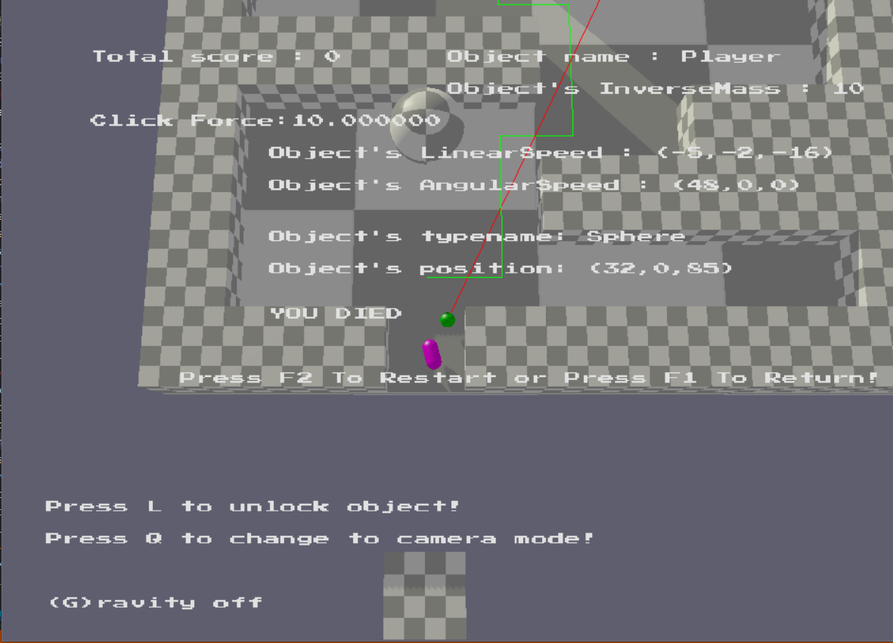
//If the score = 0,the game will be DEAD.
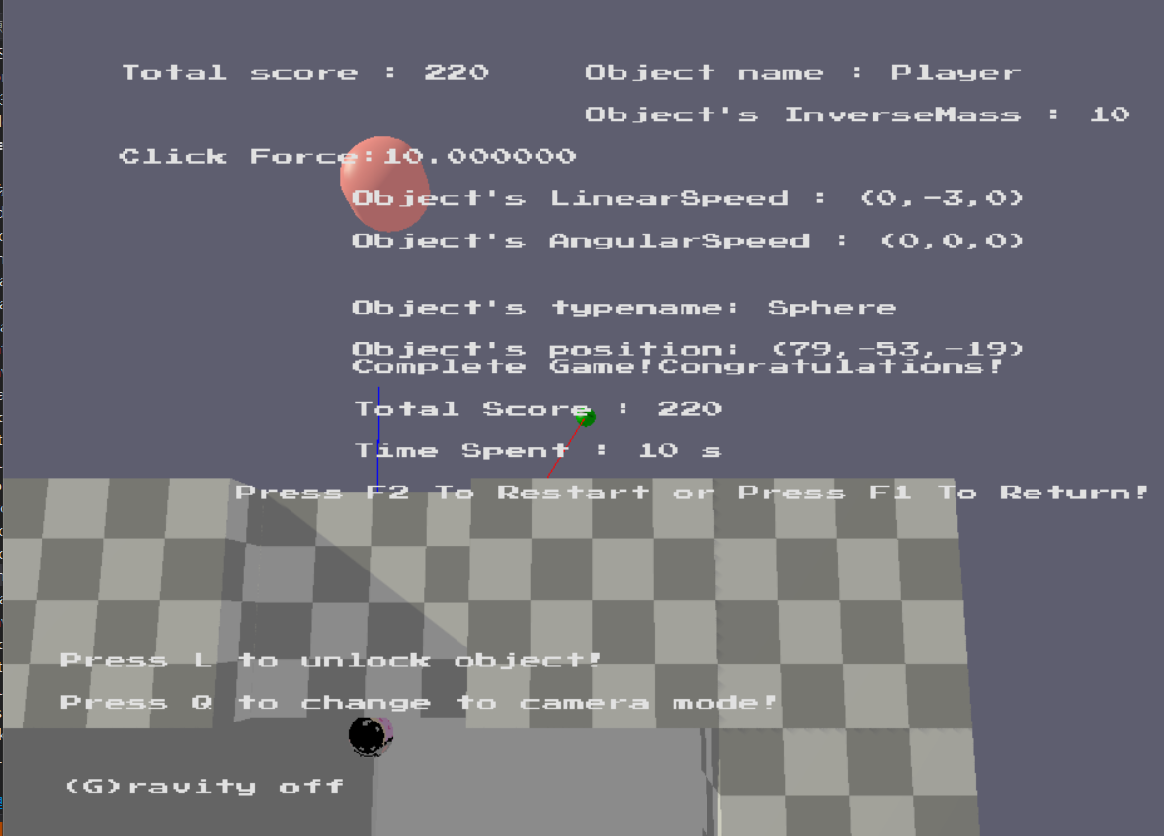
//we need to touch another “Shooter” floor at the exit of the maze to be LAUNCHED to the Pink “Destination” capsule.If we have successfully collided with the destination,we will complete the game.

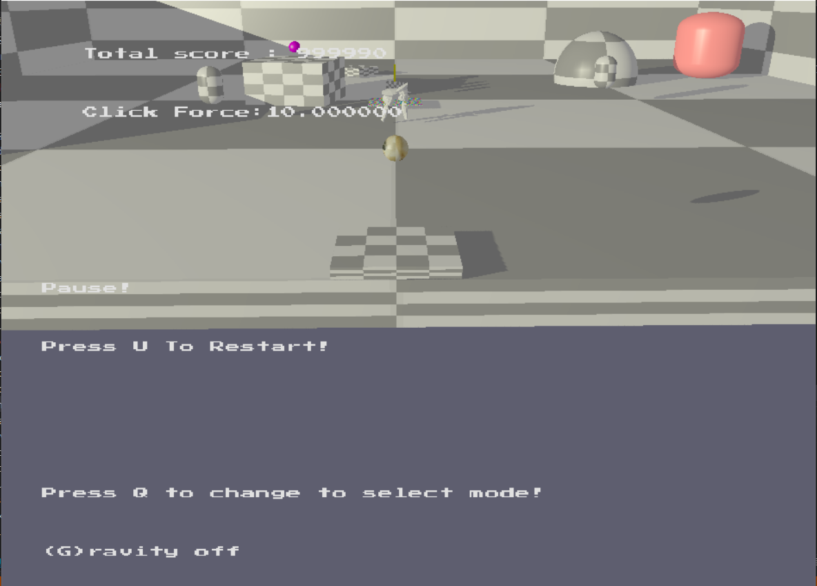
//In Part1 and Part2,we can Press F3 to enter the DEBUG mode
//In the DEBUG Mode,we have almost infinite time to play our game!We also will not be “killed” by wandering “Enemy”.

